Dead Sea Case Study

Case Study – Use of the GPR MALA HDR System in a Dead Sea Project
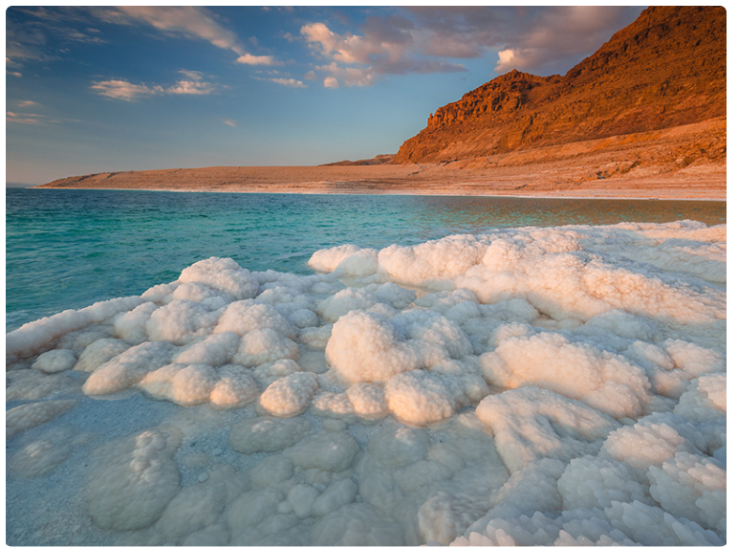

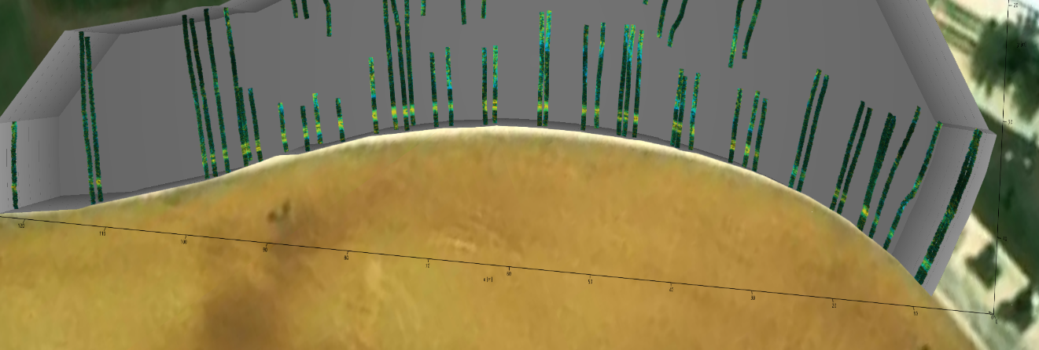

Project Background
As part of an infrastructure project in the Dead Sea region, subsurface surveys were required to locate underground utilities, buried elements, and potential subsurface hazards under some of the most challenging ground conditions in Israel.
The area is characterized by extremely high soil salinity, exceptional electrical conductivity, heterogeneous geological layers, and saturated ground conditions—factors that significantly limit the effectiveness of conventional detection methods.
To address these challenges, a GPR system based on the MALA HDR platform was selected, combined with proprietary methodologies and algorithms specifically developed and adapted by our team for extreme environmental conditions.

Environmental Challenges
- High electrical conductivity causing significant signal attenuation
- Extreme salinity reducing radar wave penetration
- Non-uniform soil stratification and complex reflection conditions
- Requirement for high accuracy while maintaining tight project schedules

The Solution – GPR MALA HDR Integrated with Our System
The MALA HDR system was selected due to its ability to operate effectively in conductive environments, offering:
- Optimized frequency performance for high-conductivity soils
- High signal-to-noise ratio (SNR)
- Flexible control of survey parameters (depth, resolution, line spacing)
- Suitability for operation in difficult and limited-access areas
Our integrated system included:
- Real-time optimization of survey parameters
- Repeated scans using multiple acquisition modes for result validation
- Advanced interpretation techniques adapted for high-salinity soils
- Cross-correlation of scan lines to generate a reliable three-dimensional subsurface model

Results and Achievements
✔️ Clear detection of subsurface elements despite extreme conductivity conditions
✔️ Significant reduction in design and planning uncertainty
✔️ Improved accuracy compared to mechanical alternatives or trial excavations
✔️ Early identification of risks, preventing delays and damage to existing infrastructure

Time and Cost Savings
Compared to traditional alternatives such as:
- Trial excavations
- Point drilling
- Less advanced electromagnetic survey methods
The project achieved:
- ⏱️ A reduction of several tens of percent in overall project timelines
- 💰 Direct cost savings in execution and supervision
- 🚫 Minimal disturbance to the site and surrounding environment
- 📉 Reduced risk of planning and construction errors

Conclusion
This project clearly demonstrates the high effectiveness of the GPR MALA HDR system when deployed in combination with professional expertise, adaptive methodologies, and advanced data-processing techniques.
Even under extreme salinity and conductivity conditions such as those found in the Dead Sea region, the system provides a reliable, fast, and accurate subsurface investigation solution, making it a preferred alternative to conventional investigation methods.

